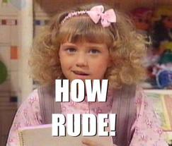
Situation 1
Student A. Your friend is rude to everyone but she thinks she is funny. Yesterday she made a joke about you that was embarrassing. And she always tells other people about your personal problems because she thinks it’s funny. Tell your friend how you feel. Give her some examples so that she understands what you mean. Try to make her understand that it’s not ok and she is hurting your feelings.
Student B. You like making jokes, especially about your friends. You are proud of your great sense of humour. You think if somebody has a problem, the best thing to do is laugh about the problem to make this person feel better. Lately your best friend hasn`t been laughing at your jokes, and yesterday, when you tried to make her feel better, she didn`t laugh either. You think she/he is too sensitive and should relax more.
Situation 2
Student A. Your friend is getting married soon. You heard a lot of bad things about her boyfriend/his girlfriend (what are these things? Think of examples!). Tell your friend what you heard.

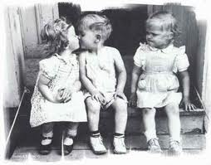
Student B. You are getting married soon and you couldn`t be happier. Your boyfriend/girlfriend is a wonderful person! But you think your friend is jealous of your happiness. Maybe she/he likes your boyfriend/girlfriend? Now your friend wants to talk to you.

Situation 3
Student A. You feel very bad about an argument you had with an old friend. Now your friend doesn`t want to talk to you. Try to explain that you were angry and didn`t want to hurt your friend’s feelings. Try to explain why you said these bad things.

Student B. You are very angry at your old friend. You argued and he/she said some bad thing to you (what did he/she say? Think of examples!). Your feelings were hurt and you won`t forgive your friend easily.

Situation 4
Student A. You want to open your own business (what kind of business?) and you want to borrow some money from your friend. You don`t want to get a loan, because the interest rate is high, and you are worried that if you don`t pay the loan back, you will lose your business. You have been friends for a long time and think friends should help each other. And whatever you friend is planning to buy can`t be more important than you opening your own business. Don`t take no for an answer!
Student B. You have been working very hard (Where?) and you saved a big sum of money, which you are planning to buy a holiday home. (Where? What kind of home?). You have wanted to have a holiday home all your life! You can`t wait to start spending your holidays there. Now your friend wants to open his own business. You think this is very risky. Also, if your friend doesn`t pay you back, your friendship will be ruined. You don`t want to lend him money. Explain, why you need the money yourself and that your friend can take a loan at a bank.

Student C. Your wife/husband’s friend wants to open his/her own business. Your wife/husband doesn`t want to lend the money to the friend, because he/she has been saving money to buy a holiday home. You think that friendship is very important and that your wife/husband should lend the money. You can always earn more money, but it’s difficult to find new friends.

